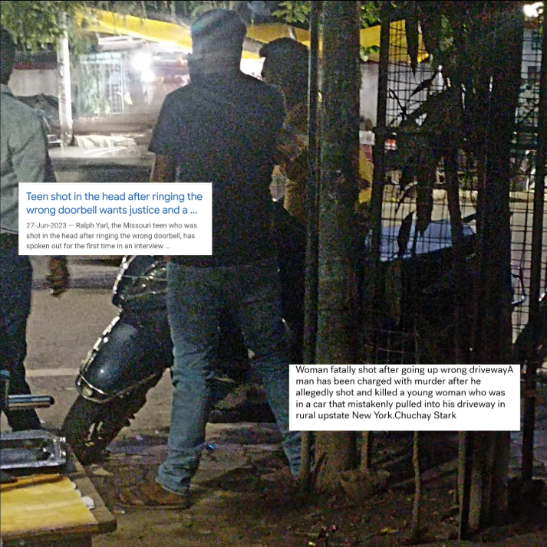

How does culture define how we see property, privacy, and our "rights" ?

In many ways- But I'll limit it to the dominant economic systems that form a part of the culture.

Look at the news clippings in the picture. I'm sure you know where they are from.

Now think of something similar happening in India- It likely strikes us as much more "out of the ordinary" than it would to someone from the USA.

You'll find lengthy discussions on quora and blogs on websites with people asking and trying to answer "Can I sh*ot someone in case X?" Yes people search it up, In hoards.

I wouldn't imagine myself being gifted with lead in my head when I ring the wrong doorbell here. And I'm not saying that people with a "gun culture" are much more comfortable with that- they are not.

Yet, It does skew the probability of something of that sort happening in a way we wouldn't want.

How much we "care" about privacy and laws has a lot to do with how much value we hold in our "property" and "individuality".

One of the projects I worked on recently told me the same- people in developing nations do not care much about government surveillance and big companies using their data as much as people from developed nations do.

In the picture- it is my scooty, as I was talking to a friend at a distance.

One moment, there was nobody, another, my scooty was the "adda" for 3 fully grown men.

Now, our nation was built on socialist values.

And this sight is all too common for every Indian person who owns a vehicle.

Someone will magically appear sitting on or supporting their backs against it.

I remained unbothered. As would most of my country people.

When would you start being angry?

The pricer the vehicle, the more angry you will be.

The more it is a part of your identity, the more angry you will be.

The stronger the sentiment of "mine" is, the angrier you will be.

In general, Someone from the US is more likely to experience negative emotions as compared to someone from India.

Stress on "likely". (For the sake of being politically correct).

